# Role/Filler Binding & Bundling

## Introduction

This code uses the Brian2 neuromorphic simulator code to implement a version of role/filler binding and unbinding based on the paper “High-Dimensional Computing with Sparse Vectors" by Laiho et al 2016.

The vector representation is a block structure comprising slots where the number of slots is the vector dimension. In each slot there are several possible bit positions with one bit set per slot.

In this implementation we implement the role/filler binding and unbinding operations in Brian2 by representing each slot as a neuron and the time delay of the neuron's spike as the bit position.

To ensure that the Brian2 network is performing correctly the first section of the code computes the expected sparse bound vector. The neuromorphic equivalent is implemented as two Brian2 networks. The first network (net1) implements the role/filler binding and the second network (net2) implements the role/filler unbinding and the clean-up memory operation which compares the unbound vector with all the memory vectors to find the best match. The sparse bound vector resulting from net1 is passed to net2 to initiate the unbinding.

These are the results for the cyclic shift unbinding using code: Role_Filler_Binding_V1_comments.py a copy of which is presented in Annex A.

## Brian2 SNN Results

The following diagram shows the neuromorphic circuit for role/filler binding/bundling.



In the following diagram we show the brian2 monitors as the binding/bundling progresses.

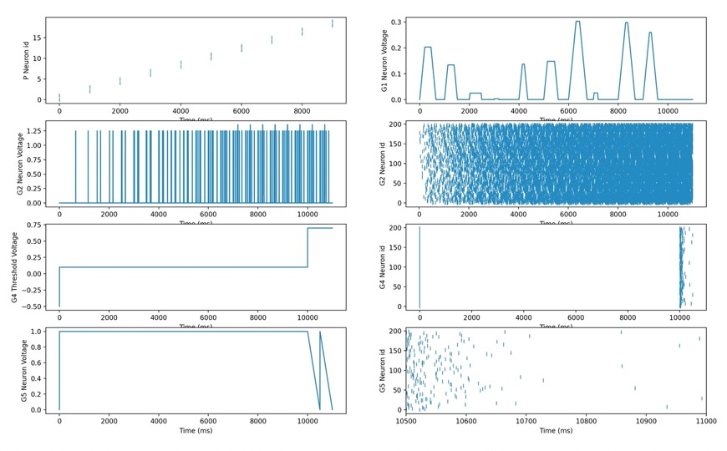

This sparse vector is now the input to the Net2 unbinding operations using the circuit shown in the following diagram.



In the following diagram we show the output as the neurons unbind the bound vector by applying the role vector to extract the corresponding filler vector. The diagram shows the sequence of actions to compute the vector difference (G6) and the corresponding clean-up memory threshold voltage and spikes produced (G8). Note that we get 2 spikes in the G8 neuron voltage and we threshold and use refractory to only get one spike from the matching neuron.



The following shows the results from binding and bundling 50 vectors with 1000 slots and 1024 bits per slot

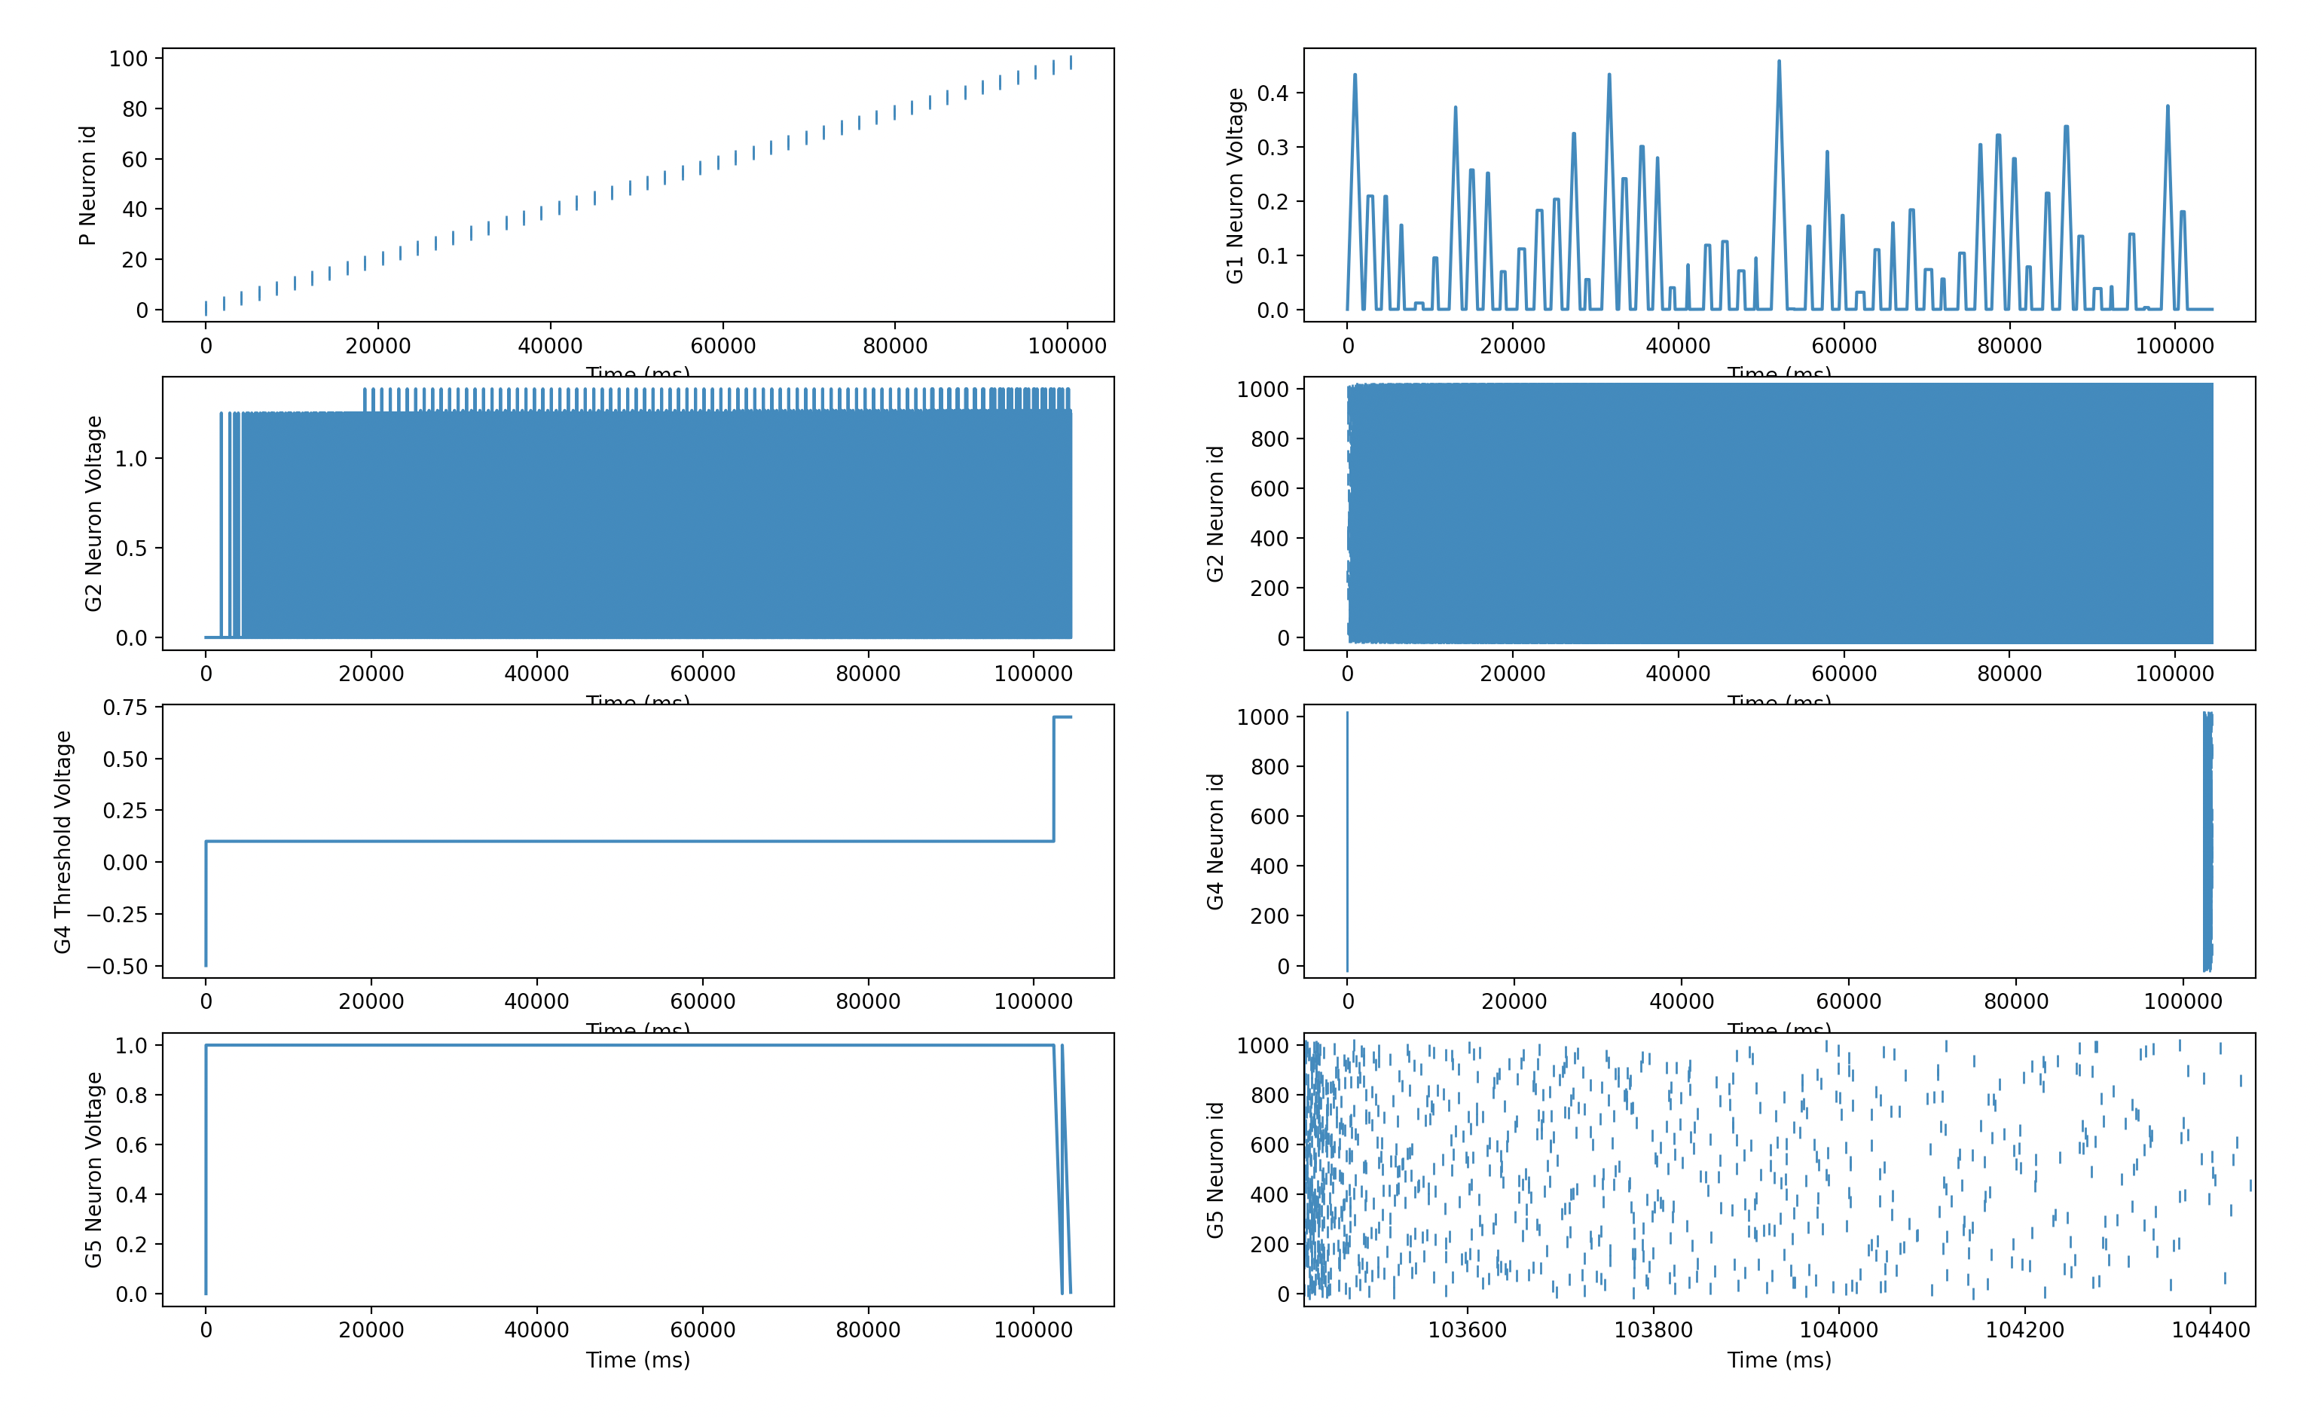

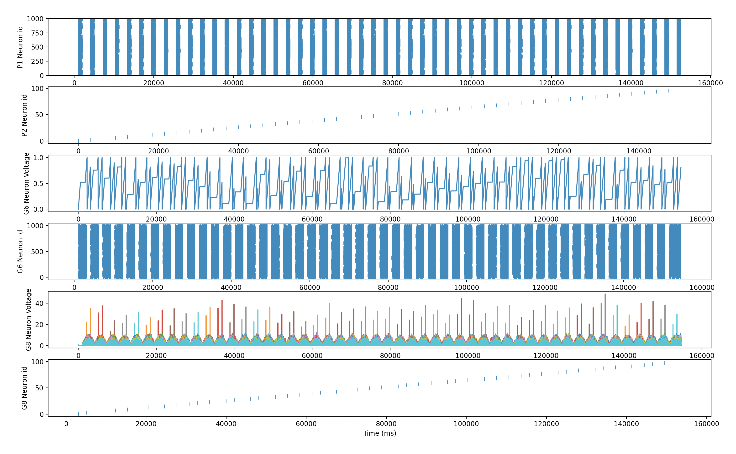

## Conclusion

The results show that we can perform role/filler binding and bundling using the sparse vector representation.

## Annex A – The Code

from brian2 import *

from brian2.equations import refractory

from brian2.monitors import spikemonitor

#import random

import matplotlib.pyplot as plt

import numpy as np

def visualise_connectivity(S):

Ns = len(S.source)

Nt = len(S.target)

figure(figsize=(10, 4))

subplot(121)

plot(zeros(Ns), arange(Ns), 'ok', ms=10)

plot(ones(Nt), arange(Nt), 'ok', ms=10)

for i, j in zip(S.i, S.j):

plot([0, 1], [i, j], '-k')

xticks([0, 1], ['Source', 'Target'])

ylabel('Neuron index')

xlim(-0.1, 1.1)

ylim(-1, max(Ns, Nt))

subplot(122)

plot(S.i, S.j, 'ok')

xlim(-1, Ns)

ylim(-1, Nt)

xlabel('Source neuron index')

ylabel('Target neuron index')

show()

#This code uses the Brian2 neuromorphic simulator code to implement

# a version of role/filler binding and unbinding based on the

# paper :High-Dimensional Computing with Sparse Vectors" by Laiho et al 2016.

# The vector representation is a block structure comprising slots

# where the number of slots is the vector dimension. In each slot there are a

# number of possible bit positions with one bit set per slot.

# In this implementation we implement the role/filler binding and unbinding

# operations in Brian2 by representing each slot as a neuron and the time delay

# of the neuron's spike as the bit position.

# To ensure that the Brian2 network is performing correctly the first section of the code

# computes the expected sparse bound vector.

# The neuromorphic equivalent is implemented as two Brian2 networks. The first network (net1) implements

# the role/filler binding and the second netwok (net2) implements the role/filler unbinding and the clean-up memory

# operation which compares the unbound vector with all the memory vectors to find the best match.

# The sparse bound vector resulting from net1 is passed to net2 to initiate the unbinding.

slots = 100 # This is the number of neurons used to represent a vector

bits = 200 # This is the number of bit positions

mem_size = 1000 # The number of vectors against which the resulting unbound vector is compared

Num_bound = 6 # The number of vectors that are to be bound

input_delay = bits # Time delay between adding cyclically shifted vectors to construct the bound vector is set to 'bits' milliseconds.

#NB all timings use milliseconds and we can use a random seed if required.

#np.random.seed(54321)

target_neuron = 1

y_low=target_neuron-1 # This is used to select the lowest index of the range of neurons that are to be displayed

y_high=target_neuron+1 # This is used to select the highest index of the range of neurons that are to be displayed

delta = (2*Num_bound+2)*bits #This determins the time period over which the Brian2 simulation is to be run.

# Generate a random matrix (P_matrix) which represents all of the sparse vectors that are to be used.

# This matrix has columns equal to the number of slots in each vector with the number of rows equal to the memory size (mem_size)

P_matrix = np.random.randint(0, bits, size=(mem_size,slots))

#print(P_matrix)

for n in range(0,2*Num_bound,2):

print(P_matrix[n][target_neuron])

print(P_matrix[n+1][target_neuron])

print((P_matrix[n][target_neuron]+P_matrix[n+1][target_neuron])%bits)

print()

print()

#--------------------------------------------------------------------------------------------------------------

#This section of the code computes the theoretical values for the sparse vector (which can then be compared with

# the output of the net1 neuromorphic circuit. It then computes the expected number of bits that will align in the

# clean-up memory operation (which can then be compared with the net2 neuromorphic circuit output).

#Create sparse bound vector (s_bound) of zeros

s_bound=[]

for s in range(0,slots):

s_bound.append(np.zeros(bits))

print()

#Create sparse representation of the bound vector

#We take pairs of vector and bind them together and in each slot

# we cyclically shift the bit position of the filler vector by the

# bit position of the role vector then we add them together to get the vector s_bound

for n in range(0,2*Num_bound,2):

for s in range(0,slots):

role_pos = P_matrix[n][s]

filler_pos = P_matrix[n+1][s]

b = (filler_pos+role_pos)%(bits)

s_bound[s][b] += 1

#make s_bound sparse using the argmax function - NB this will take the first bit position if

#non of the bits adds to greater than 1.

sparse_bound=[]

for s in range(0,slots):

sparse_bound.append(np.argmax(s_bound[s]))

print()

print(sparse_bound)

print()

#Unbind the vector sparse_bound vector and compare with each of the vectors in the P_matrix couting the

#number of slots that have matching bit positions. This gives the number of spikes that should line up

#in the clean up memory operation.

min_match=slots

for n in range(0,2*Num_bound,2):

for m in range(0,2*Num_bound,2):

match=0

for s in range(0,slots):

role_pos = P_matrix[n][s]

unbound_filler_pos = (sparse_bound[s]-role_pos)%(bits)

if P_matrix[m+1][s] == unbound_filler_pos:

match +=1

if n==m:

print()

print(n,m,match)

if match<=min_match:

min_match = match

#When we print the maximum value of match should occur when m=n

print('Min_match=',min_match)

# Generate the time delay data_matrix from the so that the input vector time delay in each slot plus the delay matrix

# line up at the number of bits per slot (e.g. a time delay in slot 0 of the input vector of say 10 will have a corresponding delay of

# 90 in the corresponding data_matrix so that if this vector is received then the match condition is an input potential to the neuron at 100)

#---------------------------------------------------------------------------------------------------------------

#This section of the code implements the role/filler binding in the Brian2 network (net1)

net1=Network()

#We first create an array of time delays which will be used to select the first Num_bound vectors from

# the P_matrix with a time delay (input_delay) between each vector.

#Calculate the array for the input spike generator

array1 = np.ones(mem_size)*slots*bits

# The input spike generator creates pairs of spkies corresponding to contiguous pairs of vectors from the memory that are

# going to be bound together (i.e., vector_0 & vector_1 then vector_2 and Vector_3 etc.)

for b in range(0,2*Num_bound,2):

array1[b] = (b)*input_delay

array1[b+1] = (b)*input_delay

# Create the corresponding spike generator group.

P = SpikeGeneratorGroup(mem_size,np.arange(mem_size), (array1)*ms)

net1.add(P)

#We now define the set of equation and reset definitions that will be used to generate the neuron action

#potentials and spike reset operations. Note that we make use of the Brian2 refractory operation.

equ1 ='''

dv/dt = (I)/tau : 1 (unless refractory)

I : 1

tau : second

'''

equ2 = '''

dv/dt = -v/tau : 1

I : 1

vt : 1

tau : second

'''

reset1 = '''

I=0.0

v=0.0

'''

reset2 = '''

vt += v

v=0.0

'''

# The G1 neurons perform the addition operation in the two selected vectors. Equ1 is a linearly increasing function

# with a time constant of 2*bits*ms (I=1.0). The G1 neuron group is stimulated from the P spike generator group with

# spikes that simultaneously select a role and filler vector using the time delay on the G1 dendrites obtained from the P_matrix (S0.delay)

# On receiving the first spike from either role or filler vector the value of I

# is changed to 0.0 which holds the neuron potential constant until the second spike is received when I = -1.0 and the neuron

# potential decays until the threshold value v<0.0 when it fires to give the required modulus addition. The value of I is

# reset to 1.0 using the spike from the P spikemonitorgroup (S1) and the next two vectors are added.

G1 = NeuronGroup(slots, equ1,

threshold='v < 0.0 or v>=1.0',reset=reset1, method='euler')

G1.v =0.0

G1.I = 1.0

G1.tau = 2*bits*ms

net1.add(G1)

S0 = Synapses(P, G1, 'w : 1',on_pre= 'I = (I-1)')

range_array1 = range(0,slots)

for n in range(0,mem_size):

S0.connect(i=n,j=range_array1)

S0.delay = np.reshape(P_matrix,mem_size*slots)*ms

net1.add(S0)

S1 = Synapses(P, G1, 'w : 1',on_pre= 'I=1.0')

for n in range(0,mem_size):

S1.connect(i=n,j=range_array1)

net1.add(S1)

# NeuronGroup G2 performs the recurrent bundling operation (note there is no cyclic shift here)

G2 = NeuronGroup(slots, equ2, threshold='v >= 1.0', reset='v=v', method='euler')

G2.v = 0.0

G2.tau = 0.5*ms

net1.add(G2)

S2 = Synapses(G1, G2, 'w : 1', on_pre='v += 1.25' )

S2.connect(j='i')

net1.add(S2)

S3 = Synapses(G2, G2, 'w : 1', on_pre='v +=1.25' )

S3.connect(j='i')

S3.delay = (bits-0.1)*ms

net1.add(S3)

# The resulting vector from the recurrent superposition operation is a dense vector.

# To create the corresponding sparse vector the G4 and G5 neuron groups work together to perform the Argmax operation.

# The G4 neurons perform part of this operation by using a variable spike threshold such that if spikes from the superposed vectors

# have the same time delay then they will only exceed the threshold if the same number of aligne spikes has not occured earlier.

# The G5 neurons then use a linear decaying neuron potential to create a single spike per slot which is the required sparse bound vector.

G4 = NeuronGroup(slots, model=equ2, reset=reset2, threshold='v>=vt',method='euler',refractory='t<(2*Num_bound)*bits*ms')

G4.v = 1.0

G4.vt = -0.5

G4.I = 1.0

G4.tau =0.25*ms

net1.add(G4)

S4 = Synapses(G2, G4, 'w : 1', on_pre='v +=1.0')

S4.connect(j='i')

net1.add(S4)

G5 = NeuronGroup(slots, equ1,

threshold='v <= 0.0', reset='v=1.0', method='euler',refractory = 't< (2*Num_bound)*bits*ms')

G5.v = 0.0

G5.I = -1.0

G5.tau = bits*ms

net1.add(G5)

argmax_synapse = Synapses(G4, G5, 'w : 1', on_pre='v = 1.0')

argmax_synapse.connect(j='i')

net1.add(argmax_synapse)

# Create the required monitors

SMP = SpikeMonitor(P)

net1.add(SMP)

M1 = StateMonitor(G1, 'v', record=True)

net1.add(M1)

SM1= SpikeMonitor(G1)

net1.add(SM1)

M2 = StateMonitor(G2, 'v', record=True)

net1.add(M2)

SM2= SpikeMonitor(G2)

net1.add(SM2)

SM4 = SpikeMonitor(G4)

net1.add(SM4)

M4 = StateMonitor(G4, 'vt', record=True)

net1.add(M4)

M5 = StateMonitor(G4, 'v', record=True)

net1.add(M5)

SM5 = SpikeMonitor(G5)

net1.add(SM5)

M6 = StateMonitor(G5, 'v', record=True)

net1.add(M6)

# Run Net1 for delta milliseconds

net1.run(delta*ms)

# Obtain the sparse vector timings from the SM5 monitor and print the timings so that they can be compared with the theoretical values.

array2 = np.array([SM5.i,SM5.t/ms])

sub_array2 = array2[0:2,slots:]

print()

sorted_sub_array2 = sub_array2[:,sub_array2[0].argsort()].astype(int) - (2*Num_bound+1)*bits

P1_timing = sorted_sub_array2[1]

print(P1_timing)

# The following plots output from the different monitors

subplot(4,2,1)

plot(SMP.t/ms, SMP.i,'|')

xlabel('Time (ms)')

ylabel('P Neuron id')

#plt.ylim(0,10)

#plt.xlim(0,2*bits*Num_bound)

#plt.xlim(9700,10800)

subplot(4,2,2)

plot(M1.t/ms, M1.v[target_neuron].T)

xlabel('Time (ms)')

ylabel('G1 Neuron Voltage')

subplot(4,2,3)

plot(M2.t/ms, M2.v[target_neuron].T)

xlabel('Time (ms)')

ylabel('G2 Neuron Voltage')

#plt.xlim(12000,14000)

'''

plot(SM1.t/ms, SM1.i,'|')

xlabel('Time (ms)')

ylabel('G1 Neuron id')

'''

subplot(4,2,4)

plot(SM2.t/ms, SM2.i,'|')

xlabel('Time (ms)')

ylabel('G2 Neuron id')

#plt.xlim(20500,21000)

#plt.ylim(y_low,y_high)

#plt.xlim(1000,1200)

#plt.xlim(0,2*bits*Num_bound)

subplot(4,2,5)

plot(M4.t/ms, M4[target_neuron].vt.T)

xlabel('Time (ms)')

ylabel('G4 Threshold Voltage')

#plt.xlim(0,2*bits*Num_bound)

#plt.xlim(19000,22000)

subplot(4,2,6)

plot(SM4.t/ms, SM4.i,'|')

xlabel('Time (ms)')

ylabel('G4 Neuron id')

#plt.ylim(y_low,y_high)

#plt.xlim(19000,22000)

subplot(4,2,7)

plot(M6.t/ms, M6.v[target_neuron].T)

xlabel('Time (ms)')

ylabel('G5 Neuron Voltage')

#plt.xlim(0,2*bits*Num_bound)

#plt.xlim(19000,22000)

subplot(4,2,8)

plot(SM5.t/ms, SM5.i,'|')

xlabel('Time (ms)')

ylabel('G5 Neuron id')

#plt.ylim(y_low,y_high)

plt.xlim((2*Num_bound+1)*bits,(2*Num_bound+2)*bits)

show()

#--------------------------------------------------------------------------------------------------------

#This section of the code implements the Brian2 neuromorphic circuit which unbinds the vector.

#The unbound vector and a selected role vector are processed to give the corresponding 'noisy' filler vector.

# which is then compared to the memory vectors to find the best match (i.e. the clean-up memory operation)

# We first generate the time delay data_matrix which will be used in the 'clean-up memory' so that the input vector

# time delay in each slot plus the delay matrix line up at the number of bits per slot

# (e.g. a time delay in slot 0 of the input vector of say 10 will have a corresponding delay of 90 in the corresponding

# data_matrix so that if this vector is received then the match condition is an input potential to the neuron at 100)

data_matrix = bits - P_matrix

net2=Network()

print()

# To pass the sparse vector from Net1 into Net2 we create a SpikeGeneratorGroup that uses the P1_timing from Net1 to generate

# the sparse bound vector which is the input to NeuronGroup G6 (S6).

P1 = SpikeGeneratorGroup(slots,np.arange(slots), P1_timing*ms)

net2.add(P1)

# We now define the neuron potential equations and resets plus a preset

equ2 = '''

dv/dt = -v/tau : 1

I : 1

tau : second

'''

equ3 ='''

dv/dt = (I)/tau : 1

I : 1

tau : second

'''

reset3 = '''

I=1.0

v=0.0

'''

preset1 = '''

I = 1.0

v= 0.0

'''

# NeuronGroup G7 is a recurrent circuit which simply repeates the sparse bound vector from P1 every 3*bits milliseconds

# and feeds the output vector into the G6 neurongroup (see S7 below)

G7 = NeuronGroup(slots, equ2,threshold='v>=1.0',reset='v=0.0', method='euler')

G7.v=0.0

G7.tau = 0.5*ms

SP17 = Synapses(P1, G7, 'w : 1',on_pre= 'v=1.25')

SP17.connect(j='i')

SP17.delay = bits*ms

S77 = Synapses(G7, G7, 'w : 1',on_pre= 'v=1.25')

S77.connect(j='i')

S77.delay = 3*bits*ms

net2.add(G7)

net2.add(SP17)

net2.add(S77)

#Calculate the array for the input spike generator which cycles through the role vectors 0,2,4 etc

array2 = np.ones(mem_size)*slots*bits

for b in range(0,Num_bound):

array2[b*2] = (b*3)*input_delay

P2 = SpikeGeneratorGroup(mem_size,np.arange(mem_size), (array2)*ms)

net2.add(P2)

#The G6 neuron group is stimulated from the P spike generator group with and the G7 neuron group.

#The P spike generator generates a role vector role using the time delay on the G6 dendrites obtained from the P_matrix (S5.delay)

# and the G6 neuron group produces the sparse bound vector.

# The G6 neurons perform the subtraction operation on the selected vectors. In this case Equ3 is a linearly increasing function

# with a time constant of bits*ms (I=1.0). On receiving the first spike from either role or filler vector the value of I=0.0

# which holds the neuron potential constant until the second spike is received when I again becomes 1.0 and the neuron

# potential continues to increase until the threshold value v>1.0 when it fires. To give the required modulus addition the value

# of I is maintained at 1.0 to ensure a second vector is generated. One of these two vector will have the correct modulus timings and so we compare both vectors in the final

# neuron group stage (G8) to get the best match.

G6 = NeuronGroup(slots, equ3,threshold='v>=1.0',reset=reset3, method='euler')

G6.v =0.0

G6.I = 1.0

G6.tau = bits*ms

net2.add(G6)

S5 = Synapses(P2, G6, 'w : 1',on_pre= 'I = (I-1)%2')

range_array2 = range(0,slots)

for n in range(0,mem_size):

S5.connect(i=n,j=range_array2)

S5.delay = np.reshape(P_matrix,mem_size*slots)*ms

net2.add(S5)

S6 = Synapses(P2, G6, 'w : 1',on_pre= preset1)

for n in range(0,mem_size):

S6.connect(i=n,j=range_array2)

net2.add(S6)

S7 = Synapses(G7, G6, 'w : 1',on_pre= 'I = (I-1)%2')

S7.connect(j='i')

net2.add(S7)

# This final NeuronGroup,G8, stage is the clean up memory operation using the transpose of the data_matrix to set the

# synaptic delays on the G8 dendrites. We only produce one output spike per match by using the refractory operator to

# suppress any further spikes. This could be improved to choose the larget matching spike.

G8 = NeuronGroup(mem_size, equ2, threshold='v >= min_match-0.5', reset='v=0.0', method='euler',refractory='2*bits*ms')

G8.v = 1.0

G8.tau = 2.0*ms

net2.add(G8)

range_array3 = range(0,mem_size)

S8 = Synapses(G6, G8, on_pre='v += 1.0')

for n in range(0,slots):

S8.connect(i=n,j=range_array3)

data_matrix2 = np.transpose(data_matrix)

S8.delay = np.reshape(data_matrix2,mem_size*slots)*ms

net2.add(S8)

# Create the required monitors

SMP1 = SpikeMonitor(P1)

net2.add(SMP1)

SM7 = SpikeMonitor(G7)

net2.add(SM7)

SMP2 = SpikeMonitor(P2)

net2.add(SMP2)

M6 = StateMonitor(G6, 'v', record=True)

net2.add(M6)

SM6 = SpikeMonitor(G6)

net2.add(SM6)

M8 = StateMonitor(G8, 'v', record=True)

net2.add(M8)

SM8 = SpikeMonitor(G8)

net2.add(SM8)

net2.run(((3*Num_bound+1)*bits)*ms)

# Plot the sparse bound vector

plot(SMP1.t/ms, SMP1.i,'|')

xlabel('Time (ms)')

ylabel('P Neuron id')

show()

# Plot the other monitors

subplot(6,1,1)

plot(SM7.t/ms, SM7.i,'|')

xlabel('Time (ms)')

ylabel('P1 Neuron id')

plt.ylim(0,slots)

subplot(6,1,2)

plot(SMP2.t/ms, SMP2.i,'|')

xlabel('Time (ms)')

ylabel('P2 Neuron id')

#plt.xlim(0,2*bits*Num_bound)

#plt.xlim(bits*Num_bound-100,2*bits*(Num_bound+1))

#plt.ylim(y_low,y_high)

subplot(6,1,3)

plot(M6.t/ms, M6.v[0].T)

xlabel('Time (ms)')

ylabel('G6 Neuron Voltage')

#plt.xlim(0,2*bits*Num_bound)

#plt.xlim(bits*Num_bound-100,2*bits*(Num_bound+1))

subplot(6,1,4)

plot(SM6.t/ms, SM6.i,'|')

xlabel('Time (ms)')

ylabel('G6 Neuron id')

subplot(6,1,5)

plot(M8.t/ms, M8.v.T)

xlabel('Time (ms)')

ylabel('G8 Neuron Voltage')

subplot(6,1,6)

plot(SM8.t/ms, SM8.i,'|')

xlabel('Time (ms)')

ylabel('G8 Neuron id')

show()